Disease dynamics

# Objectives

* Understand R0 and theeffect of vaccination on disease spread
* Understand phase portraits of disease and how they relate to time series
* See the use of models in the field

Infectious diseases spread when infected individuals contact or come near to susceptible individuals. Some diseases are easier to catch – if they are airborne and survive well outside the body, for example.

To understand and predict how any disease will spread in a population, epidemiologists calculate R0, the expected number of new infections per existing infection in a completely susceptible population. For example, if R0 is 4, we expect 4 new infections from each infection – it will spread quite rapidly at first, then a little more slowly, until just about everyone has been infected.

**Question 1.1.** What happens if R0 <1?

The scenario above assumes that the entire population starts off susceptible, but what if some individuals are immune to the infection because of genotype, acquired immunity, or vaccination? Transmission to immune individuals reduces the chance that the disease will spread. For example, if R0 is 4 but half of the contacts are immune, it can spread at only half the rate it would spread in a completely susceptible population, i.e., there would be 2 new infections per old infection. That’s still a pretty good rate of spread.

Consider the figure below. Part A shows R0 = 4 and all of the population susceptible. Part B shows what happens if ¾ of the population is immune. With this level of immunity, the fraction infected remains constant, and if more of the population is immune, the disease will decrease. The basic principle is that a disease will not take off into an epidemic if the population of susceptible individuals is small. That could be because they have become immune, have died, or have been vaccinated.

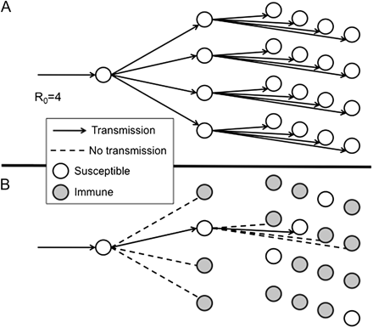

Fig. 1. Diagram illustrating transmission of an infection with a basic reproduction number R0 = 4. (A) Transmission over 3 generations after introduction into a totally susceptible population (1 case would lead to 4 cases and then to 16 cases). (B) Expected transmissions if (R0 − 1)/R0 = 1 − 1/R0 = ¾ of the population is immune. Under this circumstance, all but 1 of the contacts for each case is immune, and so each case leads to only 1 successful transmission of the infection. This implies constant incidence over time. If a greater proportion are immune, then incidence will decline. On this basis, (R0 − 1)/R0 is known as the “herd immunity threshold.” From Fine et al. (2011).

The herd immunity threshold is thus 1-1/R0. It is the fraction of the population that must be immune in order to stop the disease from spreading.

If we know R0, we can apply these ideas to determine what fraction of a population we need to vaccinate to prevent a disease from gaining a foothold in that population. But what if we don’t know R0? In that case, we can examine a mathematical model of disease spread. With each contact between an infectious host and a susceptible host, the susceptible hosts become infected at rate β (the transmission rate), which by definition decreases the proportion of susceptibles in the population.

$$\frac{dS}{dt}= -βSI$$

Where *S* is the number of susceptible individuals, and *I* is the number of infected individuals.

For this model, we assume that the disease spreads rapidly enough that we can ignore the birth of new susceptible individuals. Think of seasonal flu, an outbreak of measles, or an outbreak of Ebola virus. More complicated models are used for slowly spreading diseases, such as leprosy.

The equation above accounts for the removal—via infection—of individuals from the pool of susceptible hosts. The equation below models the addition of these individuals to the infected pool as well as the loss of infected hosts at some rate, γ, by recovery (and immunity) or by death.

$$\frac{dI}{dt}= βSI- γI$$

To determine the conditions under which the infections will stop increasing, we need to solve for the equilibrium number of susceptible individuals at which $\frac{dI}{dt}=0$.

$$\frac{dI}{dt}=0 when βSI= γI$$

The parameter γ is (1/infectious period), but β is usually estimated based on R0.This model is known as SIR (susceptible, infected, removed) for the three classes of individuals. Removed individuals can be immune or dead.

**Question 1.2.** At what value of *S* (expressed in terms of the model parameters beta and gamma) is the rate of change in infections equal to 0?

This value of *S* is the epidemic threshold: on one side of the threshold, the disease will increase to epidemic levels, and on the other side it will decrease. Again, knowing this value allows us to determine the number or fraction of the population that we need to vaccinate to prevent epidemics (even if we do not know R0). We will investigate the behavior of this model using R code and see how the dynamics play out from different starting conditions.

# Phase portraits of disease dynamics

* Download the code from Canvas.
* Start RStudio and open the R code. It has been mostly written for you, but later in the exercise you will copy and modify some lines of code to investigate model behavior with different initial conditions and parameters.

The R code first defines a function with the differential equations in it and specifies model parameters and initial conditions. It calls on ode from the package deSolve (which you will need to install if you are running this on your own computer) to solve the equations.

We put the results in a data frame called “out” that has the time intervals, the number of susceptible hosts, and the number of infected hosts at each of those times. Therefore,

plot(out[,1],out[,2])

plots the number of susceptible hosts versus time, and

lines(out[,1],out[,3])

overlays a line on the graph with the infected hosts.

The next bit of code plots infected hosts versus susceptible hosts on a graph known as a **phase portrait**, or **phase plane** or a **state space**. Points in the space of a phase portrait represent combinations of abundances of two interacting populations, or in the case of our SIR model, of two groups within a population (infected and susceptible individuals). Realize that for many models, population abundances will change along different trajectories depending on the starting conditions. We will thus vary starting conditions as we run the SIR model to examine how initial abundances of susceptible and infected individuals influence the spread of a disease in a population.

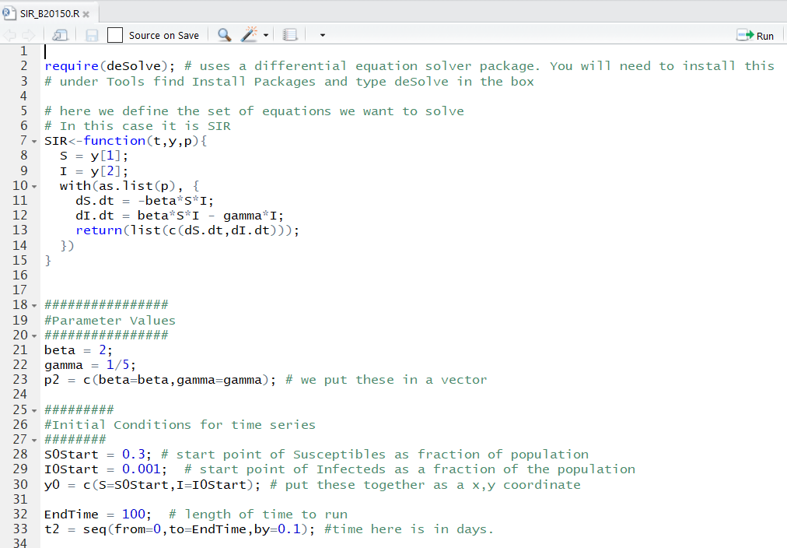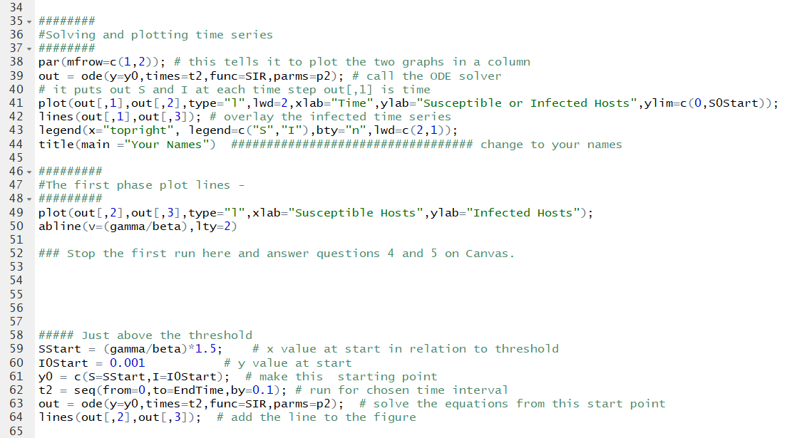

* Change line 44 so you get your names as the title of the figure.
* Run lines 1-50. You will get two plots, a time course and a phase portrait, as seen below. (If your plots look odd, expand the plot portion of the RStudio windows.)

**Question 2.** What is the vertical line on the phase portrait?

**Question 3**. Examine the graphs below. Match each point on the upper graph (time series, points A, B, and C) to the nearest corresponding point on the lower graph (phase portrait, points 1-5).

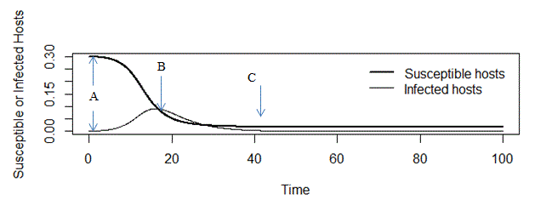

**Phase portrait**

**Time series**

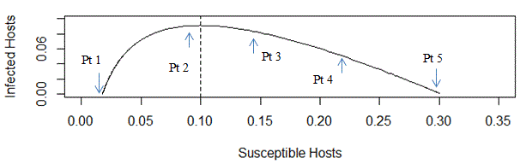

As stated earlier, the course of the outbreak will depend on the starting conditions: the fraction of the population that is susceptible (SStart) and how many infected individuals are present initially (IOStart). We’ll vary these initial conditions in the exercise below, but we will not plot the time series (upper graph) again.

* We have provided the code for the first set of starting conditions in lines 56 -63 (where it says “just above the threshold”). Run these lines of code to solve the differential equations from this new starting point and plot the outcome on the phase portrait.
* **Next, run the model with at least 4 additional starting points that you come up with**. Copy all the lines of code from 56 down to the end, paste them into the script window, and modify the SStart multiplier and the IOstart for each run. Note that SStart (starting number of susceptibles, expressed as a fraction of the population) has been defined relative to the gamma/beta value –you can try different values of that multiplier. Start some runs with the SStart multiplier >1 and some <1, but keep the multiplier less than 3. IOStart (starting number of infected individuals, expressed as a fraction of the population) should be kept <0.1.

**Question 4.** What is happening to the disease under these different starting conditions?

**Question 4.1** When the initial fraction of the population that is susceptible falls above the threshold, what happens to the time course of disease spread?

**Question 4.2** What happens when you start with an initial number of susceptibles that is below the threshold?

**Question 4.3** Are there any new infections at all when you start below the threshold?

**Question 4.4** Upload your graph to Gradescope. Make sure your names are on it.

**Question 5.** What fraction of individuals do we need to vaccinate (assuming no other source of immunity and resistance) to try to keep outbreaks of this disease from happening?

# Measles

**Question 6.1.** Measles has an estimated R0 of 12 to 18. What proportion of the population must be vaccinated to get herd immunity if R0 is 12?

**Question 6.2** What proportion of the population must be vaccinated to get herd immunity if R0 is 18?

* Examine the graph below, which depicts the fraction of the UK population vaccinated against measles between 1965 and 2010 and the number of measles cases between 1995 and 2010.

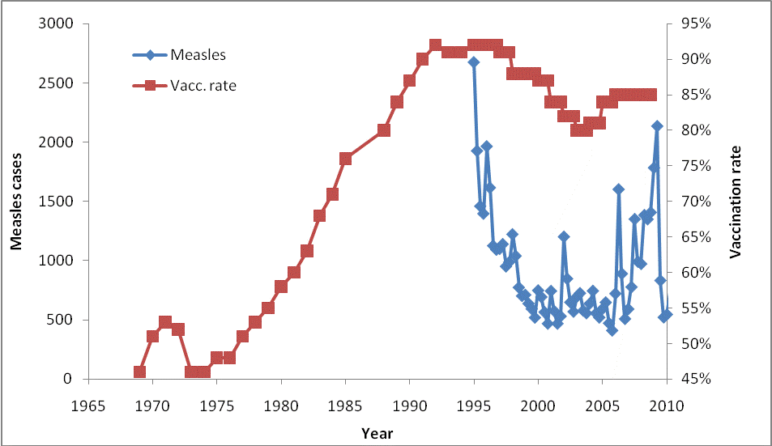

**Question 6.3.** Explain the pattern depicted in the figure in light of the answer you gave in the previous question. Note that vaccinations occur in the first year of life, but measles is more often seen in school-age children.

# Ebola – a fairly low R0

The diseases we have been considering so far have a high R0, above 10. What about something like Ebola, which has an estimated R0 around 2 (Khan et al. 2015)?

* Let’s look at the case of Ebola. Find the following parameters in your code and set them to the values given below (lines 21, 22, and 28):

Beta = 0.39

Gamma = 0.205

SOStart = 0.9

* Run the model. You may use the same sets of initial conditions as before.

There are a couple of vaccines for Ebola in development, and one that has been used in the Democratic Republic of the Congo. <https://www.niaid.nih.gov/diseases-conditions/ebola-vaccines>

**Question 7.1** If there were an effective Ebola vaccine, would it be more or less difficult to fight than the first disease modelled with the original code? Justify your answer with reference to the new figure you produced with the code.

**Question 7.2** Upload your graph of the Ebola case to Gradescope.

## Ebola Model – in the field

Can models be useful during epidemics? Yes. The CDC built and used a model of Ebola transmission to use during the 2014 epidemic. Their model includes additional pieces – once infected you incubate for a while and are not infectious, but you cannot be considered part of the susceptible class any more. They also recognized three categories of infectious individuals: at home with effective isolation; at home with no effective isolation (alive or dead unburied); or at the hospital with very effective isolation. Each of these categories has a different likelihood of transmitting the virus to another susceptible person.

* Open the Excel sheet CDC_EbolaModelnew.xls on the lab computer, or download the spreadsheet from Canvas (you will likely have to enable the editing and the content). It has several sheets, accessed via the tabs at the bottom. Results are shown as uncorrected, or “corrected.” The corrected values include their estimate that for every case they see, there are 1.5 more cases that are not counted.

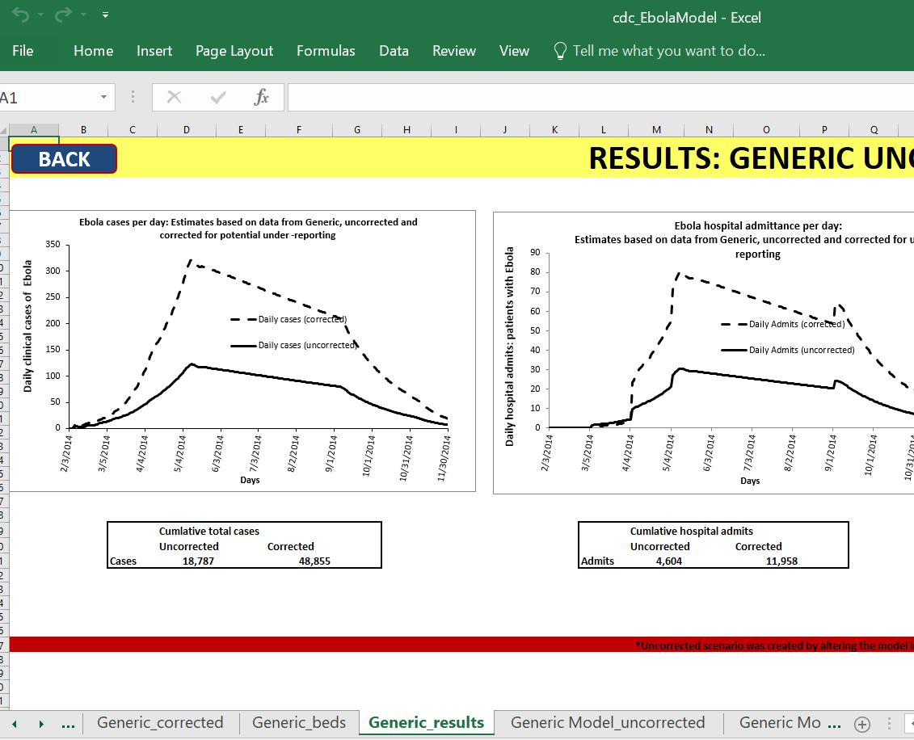

Navigation tabs for sheets

You can see their estimates of the number infected, using their best-fit parameters, on the “**Generic Results” sheet**. The cumulative number infected is underneath the first graph of Ebola cases per day. When you change a parameter, it will recalculate everything.

|  |  |  |  |
| --- | --- | --- | --- |
|  | **Transmission Risk: Daily** | **No isolation** | **DRC** |
| Hospitalized | 0.020 | 0.3 | 0.1 |
| Effective Home isolation | 0.030 | 0.3 | 0.1 |
| No effective home isolation | 0.300 | 0.3 | 1.1 |
| Total cases (uncorrected) | 18,787 |  |  |

* Run the model with **no isolation** by setting all the values for daily transmission risk on the tab “Generic uncorrected” to 0.3. What is the new total number of cases (uncorrected) on the Generic results sheet? (If you see #### as the entry, make the column wider to view the number.) The difference is the predicted effect of the international effort to combat the outbreak, by using isolation and hospitalization to decrease the transmission risk.
* In an outbreak in the Democratic Republic of the Congo, much higher transmission was found, as shown in the column of the table above labelled DRC. Enter those values on the Generic uncorrected tab and check the outcome on the Generic Results sheet – what is the new number of cases?

**Question 8.1 & 8.2.** Enter your findings for the cumulative number infected in these two scenarios, no isolation and DRC, on Canvas**.**

* **Reset** the Transmission Risk to the original values (the “Transmission Risk: Daily” column in the table above). Now go to the Population sheet and use the pull-down next to “Days people are infectious” and select 12 (double the original). Look at the total number of cases in the “Generic_results” sheet.

**Question 8.3.** What happens when you double the infectious period, and why?

## SARS COV-2

So far, we have treated the R0 as if it is a fixed entity, but it changes based on many factors, not least of which is the behavior of people such as how many contacts they have and whether they wash hands and wear masks.

The graph below shows estimates of Rt for Wuhan, China, where the outbreak was first detected. It is called Rt because it varies with time, but is still the number of new infections per old infection, but averaged over 5 days (grey indicates 95% credible intervals). We can use the fact that γ = 1/(infectious period) and Rt = β/γ to find β. Now along with much else about this novel infection, the infectious period is not known with certainty, but most sources say 10 days for mild cases and 20 days for severe cases (but these cases are typically hospitalized) so we will use 10 days.

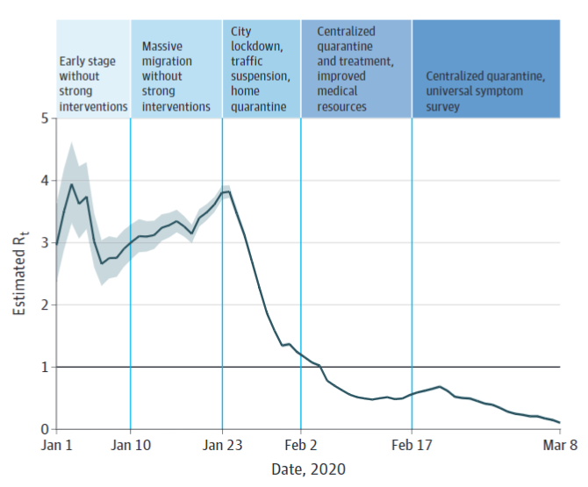Inglesby, 2020.

First for Rt at each of the stages listed in the table below, what would β (the transmission rate) be? Then we will plot and see what the epidemic threshold is and consequently what fraction of the population needs to be vaccinated to control the epidemic.

|  |  |  |
| --- | --- | --- |
|  | Rt | β |
| Early, no intervention | 3.5 |  |
| City lockdown, etc | 2.5 |  |
| Centralized quarantine, etc | 0.75 |  |

**Question 9.1** What are the values of β for each of the Rt values?

Change the parameters of the model to match the case for SARS CoV-2.

* Find the following parameters in your code and set them to the values given below (lines 21, 22, and 28):

Beta = what you calculated for Rt =3.5

Gamma = 0.1

SOStart = 0.95

* Run the model. You may use the same sets of initial conditions as before.

**Question 9.2** Upload your graph (PNG, BMP, GIF) to Gradescope.

**Question 9.3** What fraction of the population needs to be vaccinated to prevent an outbreak if no other intervention is taken?

## References cited

Fine, Paul, Ken Eames, and David L. Heymann. 2011. “Herd Immunity”: A Rough Guide. Clin Infect Dis. (2011) 52 (7): 911-916. doi:10.1093/cid/cir007

Inglesby TV. Public Health Measures and the Reproduction Number of SARS-CoV-2. JAMA. 2020;323(21):2186–2187. doi:10.1001/jama.2020.7878

Khan A, Naveed M, Dur-e -Ahmad M, Imran M. 2015. Estimating the basic reproductive ratio for the Ebola outbreak in Liberia and Sierra Leone. Infectious Diseases of Poverty 4:13. doi:10.1186/s40249-015-0043-3.

Meltzer MI, Atkins CY, Santibanez S, Knust B, Petersen BW, Ervin ED, Nichol ST, Damon IK, and Washington ML. 2014. Estimating the future number of cases in the Ebola epidemic--Liberia and Sierra Leone, 2014-2015. MMWR Suppl. 2014 Sep 26;63(3):1-14. Centers for Disease Control and Prevention (CDC).

